**5.1 Motivation\***

* Motivation is the driving force behind our actions
  + Extrinsic: based on external circumstances
  + Intrinsic: based on internal drive or perception

Instinct Theory

* In the instinct theory of motivation, people perform certain behaviors because of these evolutionarily programmed instincts
* Instincts = **innate**, fixed patterns of behavior in response to stimuli
  + May or may not disappear with time

Arousal Theory

* People perform actions to maintain arousal, the state of being awake and reactive to stimuli, at an optimal level
* The **Yerkes-Dodson law** shows that performance is optimal at a medium level of arousal
  + Lower levels are optimal for highly cognitive tasks
  + Higher levels are optimal for activities that require physical endurance and stamina
  + Simple tasks require slightly higher arousal than complex tasks

Drive Reduction Theory

* Drives are internal states of **tension** that beget particular behaviors focused on **goals**
* The theory states that motivation arises from the desire to **eliminate drives**, which may cause **uncomfortable internal states**
  + Primary drives are those that motivate us to sustain necessary biological processes e.g. negative feedback loop by hypothalamic-pituitary-adrenal axis (homeostasis)
  + Secondary drives are those that motivate us to fulfil nonbiological, emotional, or “learned” desires e.g. wanting to get into med sch

Need-based Theories

1. Maslow’s hierarchy of needs (from highest to lowest priority)
   1. Physiological needs
   2. Safety and security
   3. Love and belonging
   4. Self-esteem
   5. Self actualization
2. Self-determination theory (3 universal needs for healthy relationship)
   1. Autonomy - in control of one’s actions and ideas
   2. Competence - complete and excel at difficult tasks
   3. Relatedness - feel wanted and accepted in relationship

Additional Theories and Applications

1. Incentive theory explains motivation as the desire to pursue rewards
   1. Focuses on **positive reinforcement**
2. Expectancy-value theory states the amount of motivation for a task is based on the individual’s **expectation** of success and the amount that success is **valued**
3. Opponent-process theory explains motivation for drug use
   1. As drug use increases, the body **counteracts** its effects, leading to tolerance and uncomfortable withdrawal syndromes
   2. E.g. Cocaine is a stimulant, causing euphoria, restlessness, increased heart rate, increased temperature, and anxiety
      1. According to the theory, cocaine withdrawal should be the opposite: depressed mood, fatigue, decreased heart rate, decreased temperature, and apathy

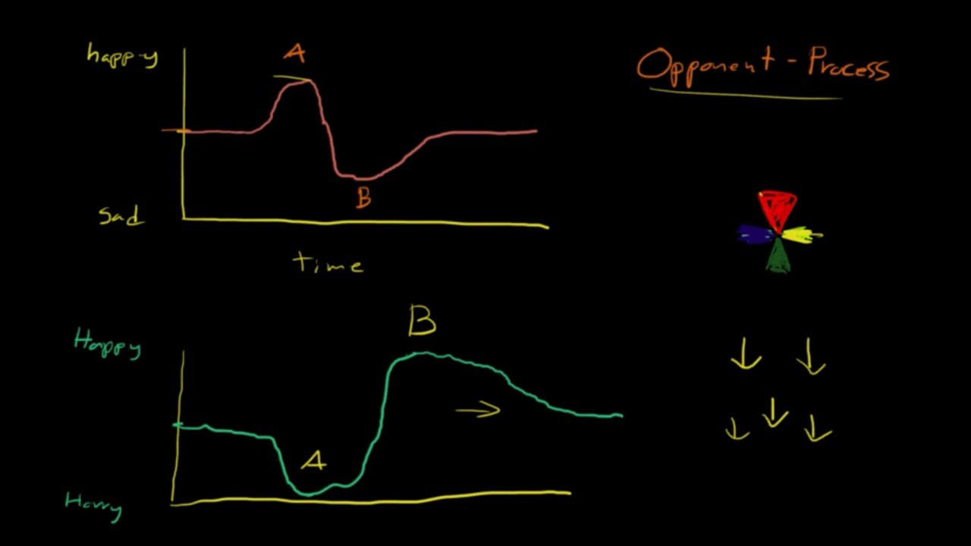

1. Sexual motivation is related to hormones as well as cultural and social factors

**5.2 Emotion\***

* A state of mind, or feeling, that is subjectively experienced based on circumstances, mood, and relationships

Three Elements of Emotion

1. Cognitive (subjective)
2. Behavioural (facial expressions and body language)
3. Physiological (changes in autonomic nervous system)

Universal Emotions

* **Happiness, sadness, contempt, surprise, fear, disgust, and anger**

Adaptive Role of Emotion

* Emotions are thought to be evolutionary adaptations
  + Primal: fear
  + More evolutionarily progressive: social emotions e.g. guilt and pride

Theories of Emotion

1. James-Lange Theory
   1. Nervous system arousal leads to a cognitive response in which the emotion is labeled (stimulus → physiological → cognitive → behavior)
   2. Weakness: spinal cord injury subjects continue to show the same level of emotion after their injuries as before
2. Cannon-Bard Theory
   1. The **simultaneous** arousal of the nervous system and cognitive response lead to action (stimulus → physiological & cognitive → behavior)
   2. Weakness: Vagus nerve, a cranial nerve that functions as a feedback system, conveying information from the peripheral organs back to CNS)
3. Schachter-Singer Theory
   1. Also termed the cognitive arousal theory, or the two-factor theory
   2. Nervous system arousal + **interpretation** of context → cognitive response

The Limbic System

* The primary nervous system component involved in experiencing emotion

1. Amygdala
   1. Involved with attention and fear
   2. Helps interpret facial expressions
   3. Part of the intrinsic memory system for emotional memory (unconscious/ implicit memories)
2. Thalamus
   1. Sensory processing station
3. Hypothalamus
   1. Releases neurotransmitters that affect mood and arousal
4. Hippocampus
   1. Creates long-term explicit (episodic) memories
5. Prefrontal cortex → involved with planning, expressing personality, and making decisions
   1. Ventral prefrontal cortex → critical for experiencing emotion
   2. Ventromedial prefrontal cortex → involved in controlling emotional responses from the amygdala and decision-making

**5.3 Stress\***

* The psychological and cognitive response to challenges or life changes

Cognitive Appraisal of Stress

1. Primary appraisal (determines if there is a negative association at all)
   1. Classifying a potential stressor as irrelevant, benign-positive, or stressful
2. Secondary appraisal (determines intensity and risk of stressor)
   1. Directed at evaluating if the organism can cope with the stress

Types of Stressors

* A stressor is anything that leads to a stress response

1. Distress → experiencing unpleasant stressors
2. Eustress → result of positive conditions (e.g. life events such as marriage)
3. Significant life change (e.g. going to college for the first time)
4. Catastrophe (natural disaster)
5. Daily hassle (e.g. forgetting your keys, racism)
6. Ambient (e.g. poor air quality in the environment)

Physiological Response to Stressors (General Adaptation Syndrome)

* **People’s response to various stressors is similar**; the type of stressor does not really matter

1. Alarm
   1. Initial reaction to a stressor → activation of SNS
   2. CRH (from hypothalamus) → ACTH (from pituitary) → ...
      1. Cortisol (adrenal glands) → sugar supply
      2. Epinephrine and norepinephrine (from adrenal medulla) → activate SNS
2. Resistance
   1. Continuous release of hormones → SNS continues to fight the stressor
3. Exhaustion
   1. Body unable to maintain and elevated response with SNS activity → becomes susceptible to illness and medical conditions

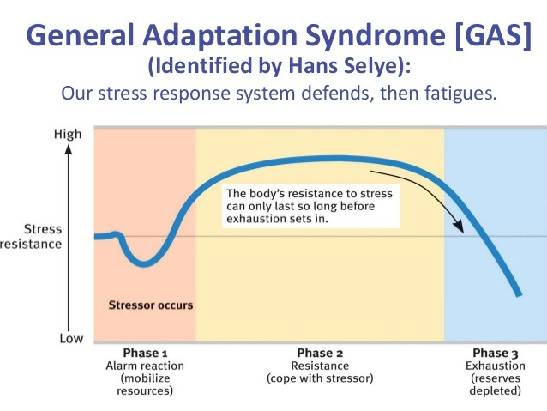

Emotional and Behavioral Responses to Stress

* Individuals can feel irritable, moody, tense, fearful, and helpless

Coping

1. Problem-focused strategies
   1. Involved working to overcome a stressor e.g. reaching out, confronting the issue
2. Emotionally-focused strategies
   1. Centered on changing one’s feelings about a stressor e.g. engaging in self control, or turning to drugs

Stress Management

* Exercise → releases endorphins, opioid neurotransmitters
* Meditation, diaphragmatic breathing, progressive muscle relaxation